**Eclipse install for SAP ABAP development, support, and innovation - 2024 edition**

Prepared by Ryan Fleischmann

*Installation of Eclipse for SAP Development also requires installation of Java - so instructions on Java install are also provided as a prerequisite.*

*Highly recommend you have admin rights to your PC during the install - specifically for installing and configuring the JDK (Java Developer Kit) on your machine. Downloading and extracting a zip file often works better in cases where running an installer is not possible*

**Recommended versions**

Java: JDK version 11 (JDK version 11 was previously not supported by SAP, you may need update from version 8 to version 11)

Eclipse: Refer to <https://tools.hana.ondemand.com/> for selecting best Eclipse install for SAP install. As of December 2023, here are the supported plugins for each

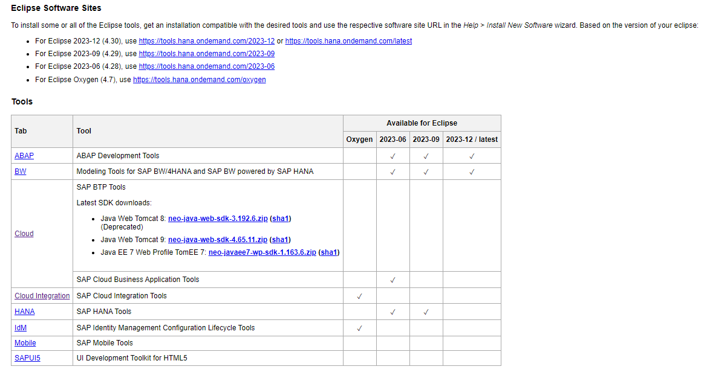

As of December 2023, 2023-06 is the best install - but depending on project requirements you could need to install other older or newer versions of Eclipse. Multiple Eclipse installs are supported, but separate install location and workspaces should be assigned to each install. This is best accomplished using a ZIP extract of the Eclipse installation.

**JDK and Eclipse compatibility**

Ensure your JDK and Eclipse match in terms of 32 and 64 bit

If you install 32 bit JDK, install 32 bit Eclipse

If you install 64 bit JDK, install 64 bit Eclipse

32 bit JDK won’t work with 64 bit Eclipse

64 bit JDK might work with 32 bit Eclipse, but may have issues

I recommend the 64 bit install as that allows for a broader variety of apps to be installed on your machine. But, you may do just fine with 32 bit versions.

**Download and install JDK**

*Oracle*

<https://www.oracle.com/java/technologies/downloads/#java11-windows>

For 64 bit install - select

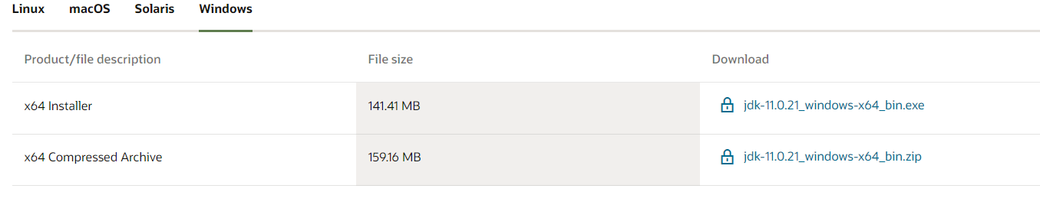

Run the .exe

Sometimes your client may have licensing issues with Oracle - so you can otherwise also download and install a JDK 11 from an alternative provider

*Amazon Corretto*

https://docs.aws.amazon.com/corretto/latest/corretto-21-ug/downloads-list.html

*OpenJDK*

https://www.freecodecamp.org/news/install-openjdk-free-java-multi-os-guide/

Go to the control panel advanced system settings

Add environment variables for JAVA_HOME and JRE_HOME

These will refer to the directories where you installed the JDK and JRE respectively.

Likely will be under C:\Program Files\Java

**Validate installed Java version**

If you have Java/JDK already installed, you may wish to simply check the version of the JDK installed you can do this by typing java -version in the command line

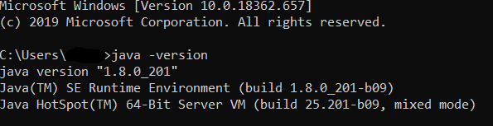

**Download and install Eclipse**

**** Make sure the bit version (64 bit or 32 bit) matches the JDK you just installed ****

**** This is really important. Eclipse won’t work if you get this wrong ****

*ALSO VERY IMPORTANT!!*

Eclipse may not really work that well without the JDK installed. A Java runtime (JRE) may be sufficient. You really need Java installed for Eclipse.

Your desired Eclipse install should be listed here

<https://www.eclipse.org/downloads/packages/>

You may need to look for a section titled “More downloads” to locate the download.

Once downloaded, create a new directory under your user folder named eclipse. Extract the zip file of the Eclipse install download to this directory.

**Test install**

Go to the directory where you installed Eclipse and open Eclipse.exe

If install is successful - you’ll see a dialog like this prompting you to select a workspace. Use the same workspace every time for your Eclipse installation.

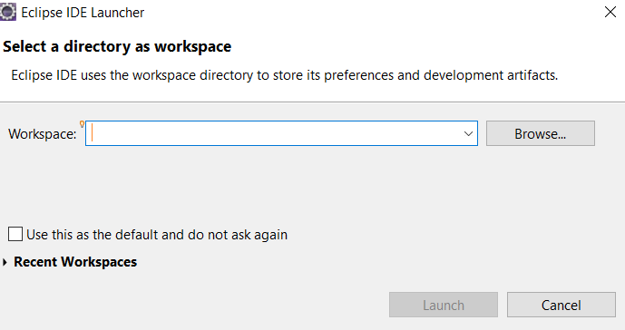

If this is your 2nd or more Eclipse install, make sure you create a new folder for the Eclipse workspace. Multiple eclipse installations should not share workspaces.

**Add SAP Development tools**

Once Eclipse is open, go to Help>Install New Software

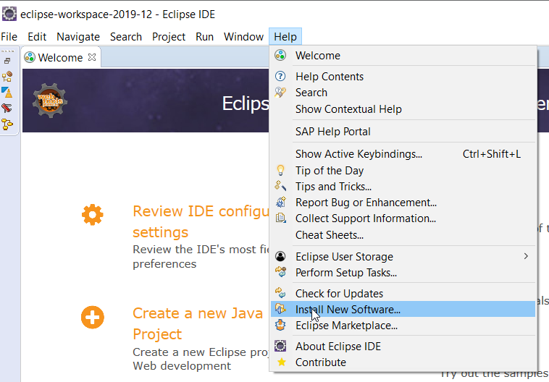

Add new entry according to your selected version of eclipse

* <https://tools.hana.ondemand.com/2023-12> or <https://tools.hana.ondemand.com/latest>
* <https://tools.hana.ondemand.com/2023-09>
* <https://tools.hana.ondemand.com/2023-06>
* <https://tools.hana.ondemand.com/oxygen>

Once added - select the plugins you need and click next

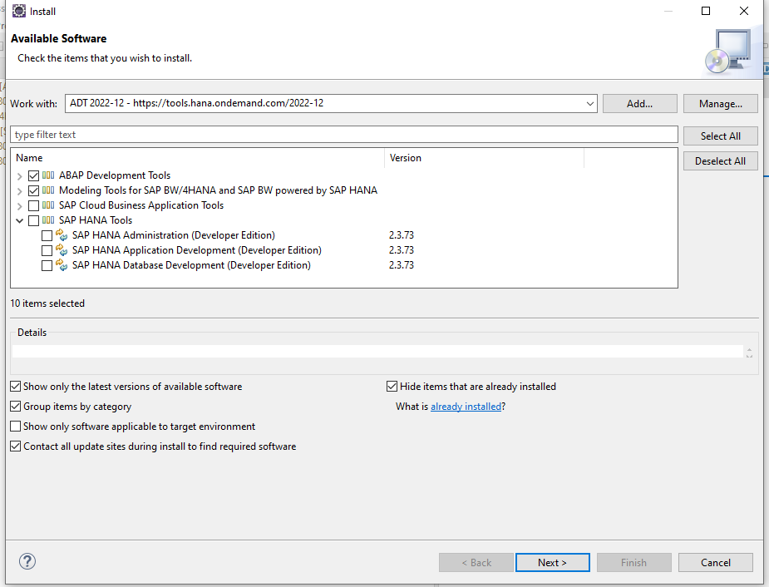

Click finish to proceed with the install

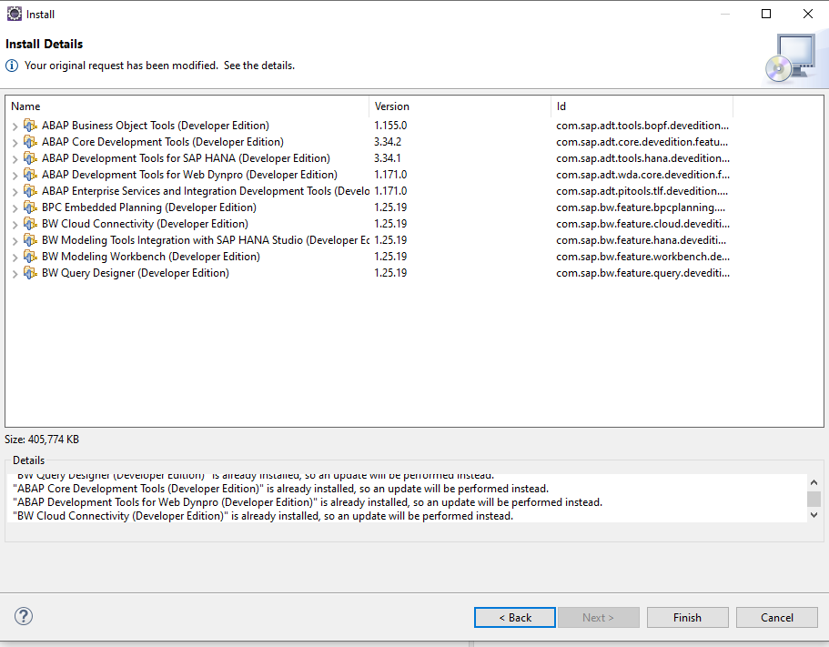

The installation *is not done yet!*

Watch the progress percentage in the bottom right hand corner



*Do not close* Eclipse before this completes. That can mess up your whole Eclipse install in a way you have to do everything all over again.

Might a good time to grab some coffee - but do check for popups.

Once installed, Eclipse will need to restart.

**ON PREMISE Connectivity**

**Connect Eclipse to SAP ABAP System on-premise**

**Pre-req: Must have SAP Logon pad installed with connection configured. The ADT ICF service must also be active**

**Validate SAP-Eclipse ABAP connectivity**

File > New > ABAP Project

You will see the same connection that were configured in the logon pad. Select your system and login.

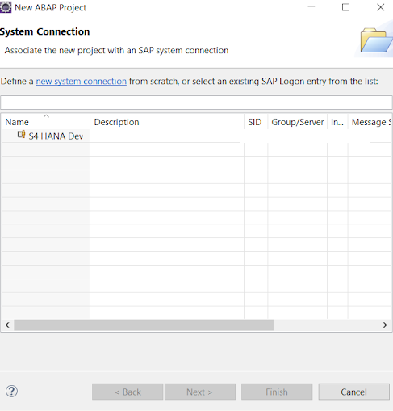

Report any authorization errors to your security team. Typically you’ll need to request authorization to the ADT ICF service. This is part of the standard SAP developer role and your security contact can find and add it quite easily.

However, assuming you are successful - you’ll now be able to navigate the system library from the package level. These are the same packages you would see in SE80.

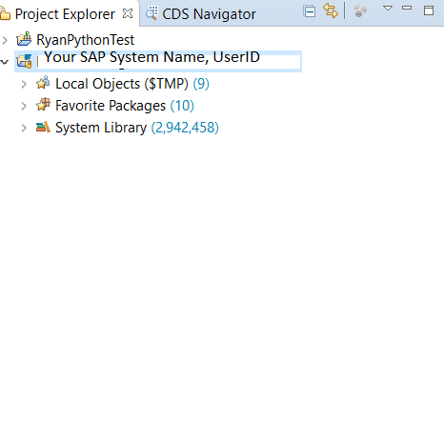

**STEAMPUNK (ABAP on BTP) Connectivity**

After installing the aforementioned plugins - the following is needed in BTP

Pre requisite: setup ABAP steampunk. This is done rather easily using the ABAP Trial booster!

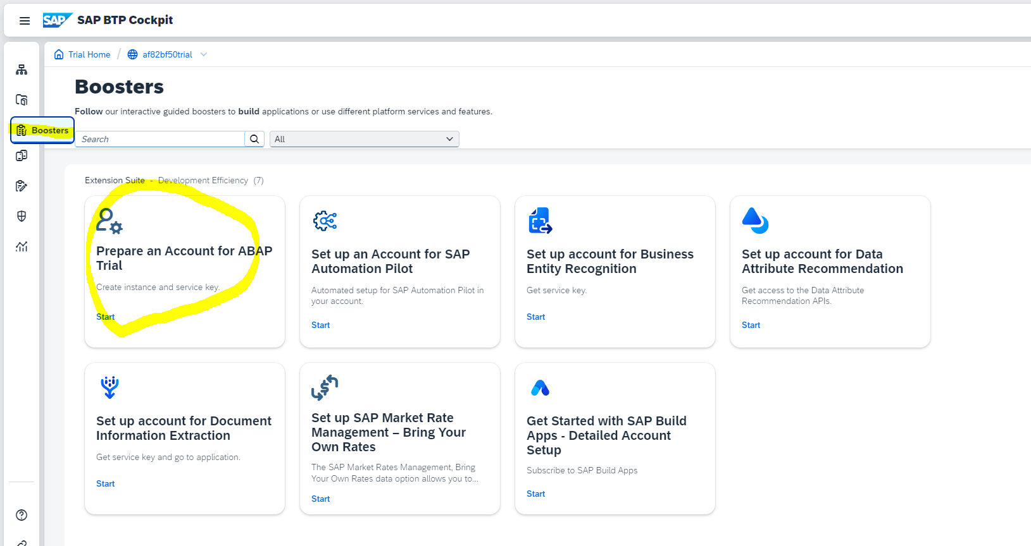

Once you successfully complete the steps in the booster you should see your ABAP trial instance available

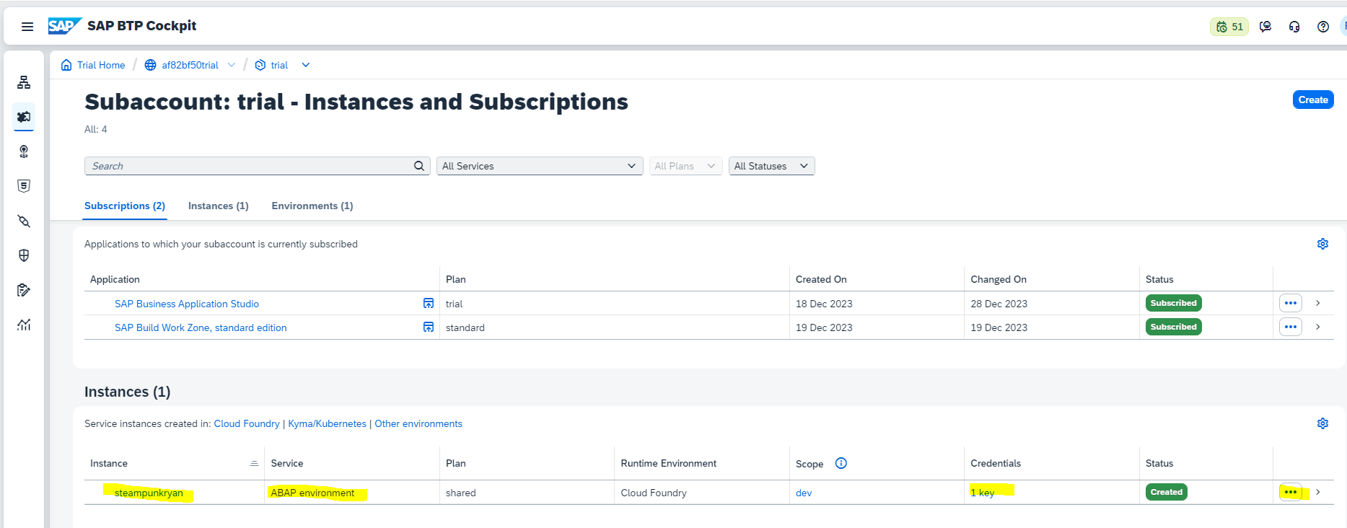

Download the service key either by selecting the credentials key under the instance. You can always generate a new key from the 3 dots.

Download the key

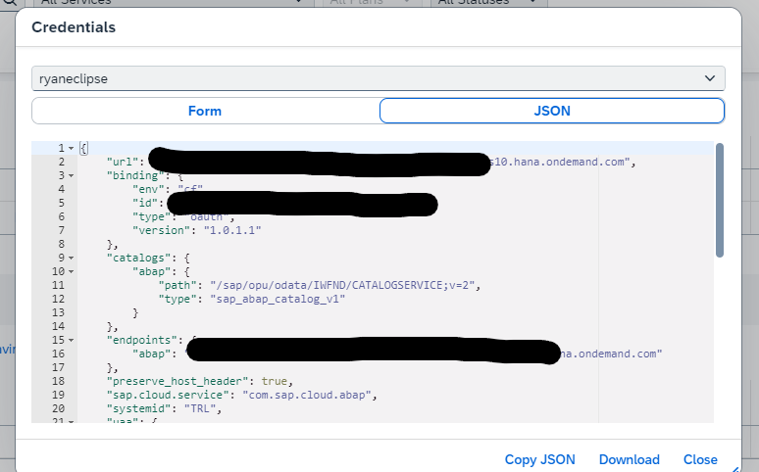

Back in Eclipse Select New > ABAP Cloud Project

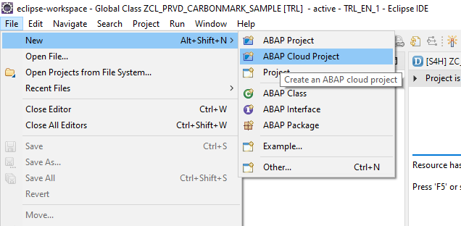

Upload the service key

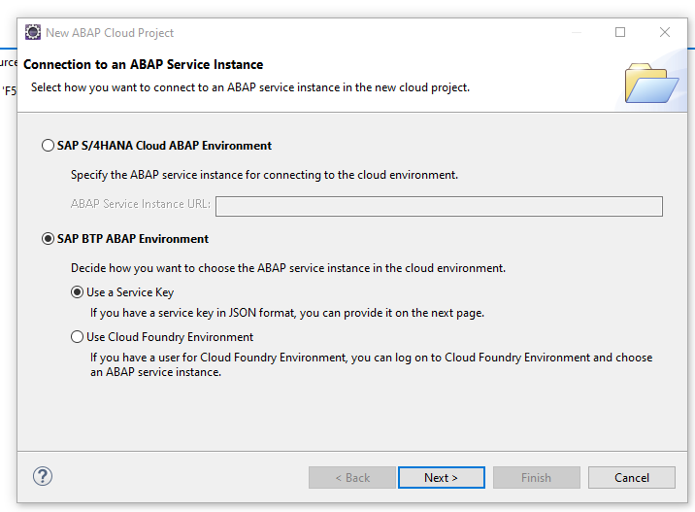

You’ll log on one more time and then you’re in! For ABAP trial - you’ll need to develop packages under ZLOCAL project

**Congratulations! Your Eclipse installation is now integrated with your SAP ABAP Systems :)**

***Like this content?***

Feel free to show me your appreciation here:

<https://www.buymeacoffee.com/ryfleisch>

***Q&A, support, license***

Go to <https://github.com/fleischr/abap-eclipse-guide/blob/main/README.md> for open source license info, feedback, or any other questions/support